|  |  |  |
| --- | --- | --- |
| **Supervisor** | SIR OWAIS AHMED | |
| **Batch** | 2301C2 | |
| **Group** | **B** | |
| **Serial No.** | **Enrollment Number** | **Student Name** |
| 1. | Student1470409 | MUHAMMAD TAHA NADEEM |
| 2. | Student1472855 | ABDULLAH KASHIF |
| 3. | Student1471106 | MUHAMMAD HASEEB SHAHID |
| 4. | Student1471189 | REHAN AHMED |

# Navbar:

Using the navbar, the user can navigate through various categories. We have total 7 items in Navbar, which are further classified as:

* AUCTIONS
* SELLS
* HOW IT WORKS
* COLLECTIONS
* ABOUT US
* CONTACT US
* REGISTER

Auctions Page includes 3 more categories (Today’s Auctions, Completed Auctions, Join Auctions). Collections Page include 8 more categories/pages. Each page contains total 9 items. 

Products slider includes our collections items and its categories. 

Footer contains about our company, services, account and our categories.



# Sell Page:



**Collections Categories**

We have total 8 categories; each category contains 9 items. And every item contains products details page, so we have total 144 pages of collections category. But in this documentation, we will share the 1 items detail.

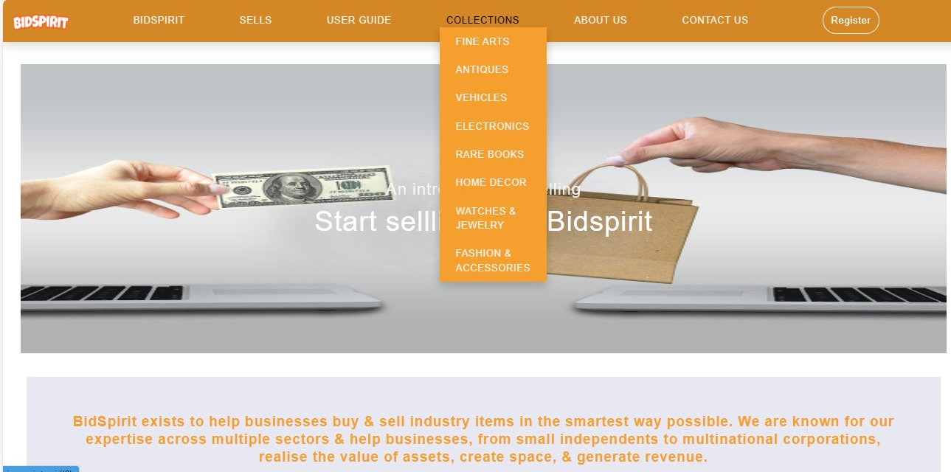

**Collections Categories**

**Category No 1 Antiques**



**Category No 2 Vehicles**



**Category No 3 Fine Arts**



**Category No 4 Rare Books**



**Category No 5 Electronics**



**Category No 6 Home Décor**



**Category No 7 Fashion & Accessories**



**Category No 8 Watches & Jewelry**



**About Us Page:**



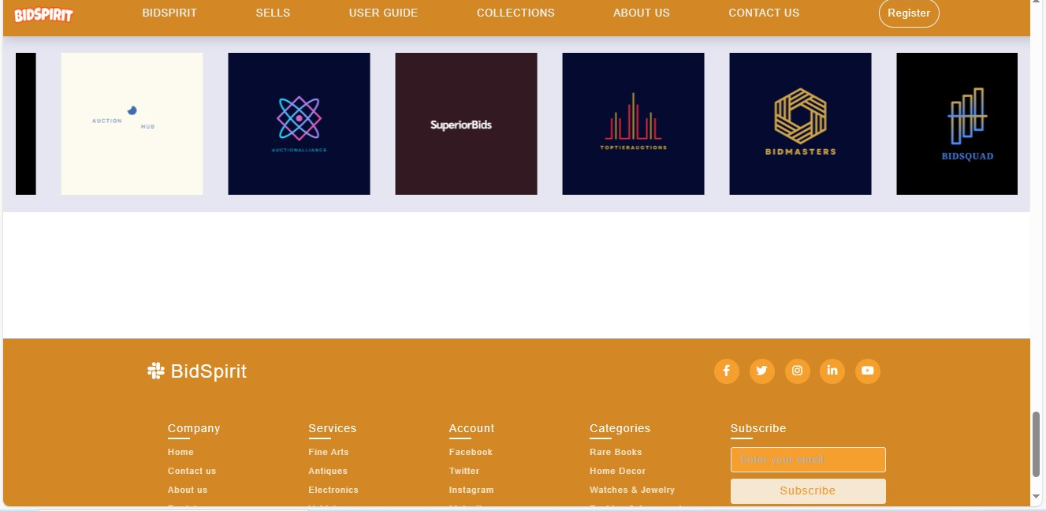

**Contact Us Page:**



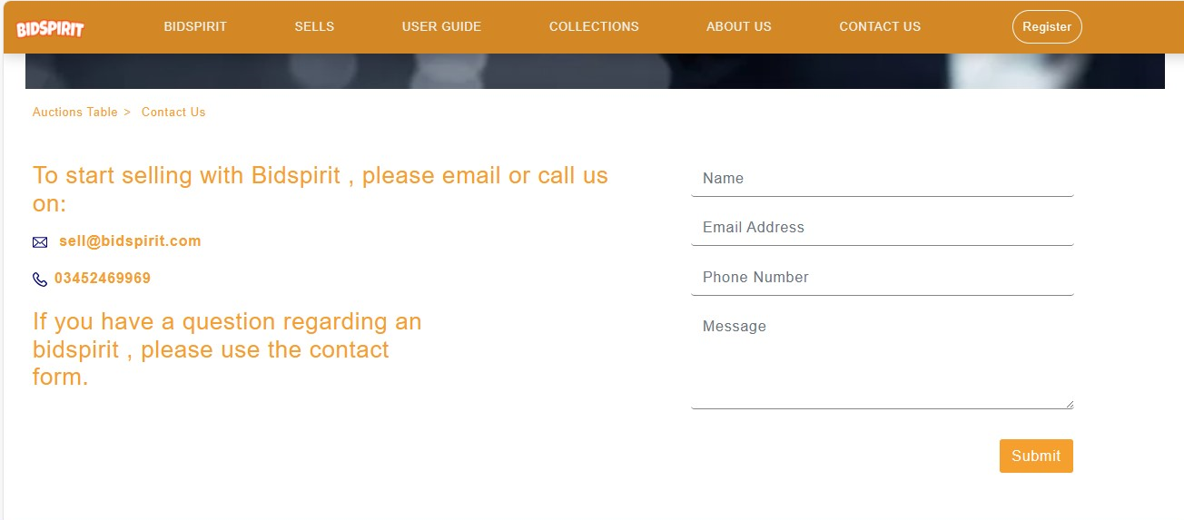

**Register Page:**

We use video in Background.

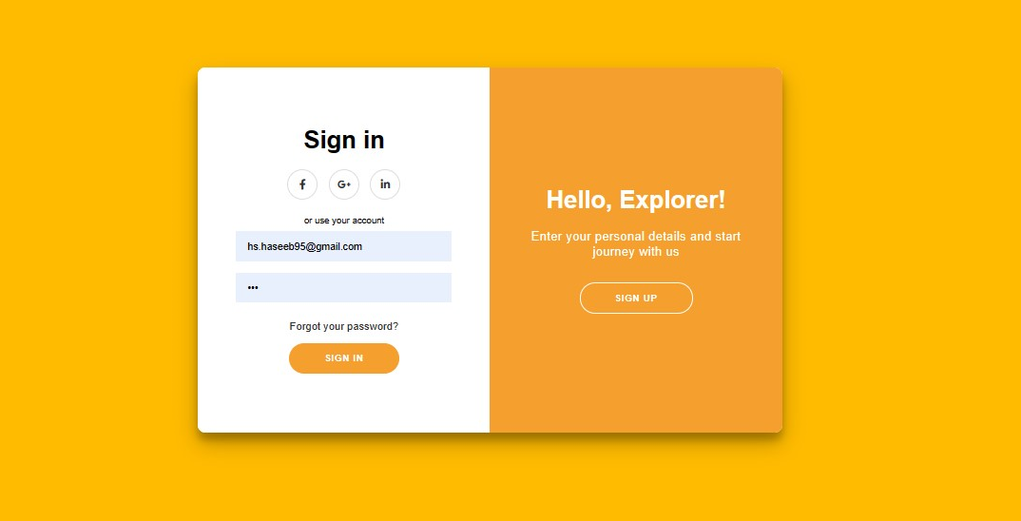

**Footer Page:**

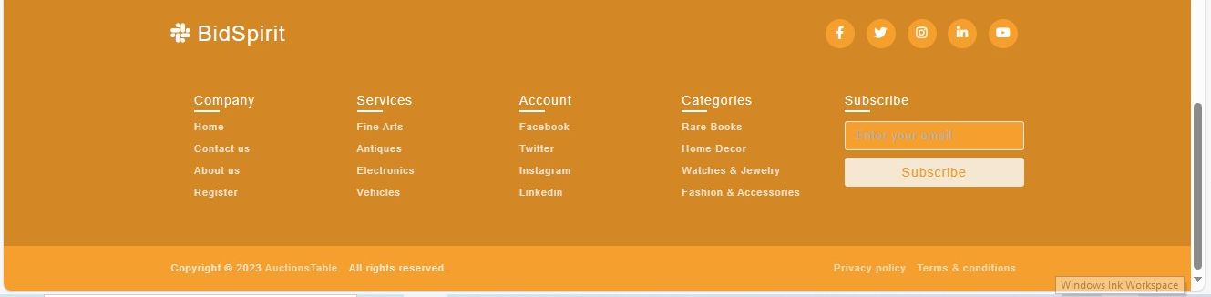

**Summary:**

The "Auctions Table" project documentation presents a comprehensive solution for the streamlined management and analysis of auction data. With the rapid growth of online marketplaces and the increasing popularity of auctions, it has become crucial to have a robust system in place to effectively organize and analyze auction-related information.

The project begins by outlining the objectives, requirements, and scope of the Auctions Table system. It emphasizes the need for a user-friendly interface that allows users to input, modify, and retrieve auction data seamlessly. Additionally, it highlights the importance of incorporating advanced analytical features to derive meaningful insights from the collected data.

Next, the documentation delves into the system architecture, illustrating the various components and their interactions. The Auctions Table system utilizes a combination of database technologies, such as relational databases or NoSQL databases, to ensure scalability and efficient data retrieval. The project also incorporates data encryption and access control mechanisms to maintain data security and privacy.

The documentation further details the key functionalities provided by the Auctions Table system. It outlines the process of creating and managing auction listings, tracking bids and auction progress, and facilitating smooth transactions between buyers and sellers. Moreover, it highlights the integration of data visualization tools to present auction statistics, trends, and patterns in a visually appealing manner.

To ensure optimal performance and usability, the project documentation describes the rigorous testing and evaluation procedures employed during the development phase. It covers the techniques used to verify the system's functionality, assess its reliability, and validate its performance under different scenarios.

Finally, the documentation concludes with a discussion on potential future enhancements and expansions for the Auctions Table system. It suggests avenues for incorporating machine learning algorithms to automate bid prediction or fraud detection, as well as integrating with external platforms for seamless data exchange.

In summary, the Auctions Table project documentation presents a comprehensive solution for efficiently managing and analyzing auction data. By leveraging advanced technologies and incorporating user-friendly interfaces, the system aims to revolutionize the way auction-related information is organized, processed, and utilized.